


Developing a Path of Discipleship / “Proven Process”
for Congregational Membership and Leadership Development

Matt Vogt (Email: matthew.vogt@wels.net Cell: #702-417-8863)

“Christ himself gave . . . pastors and teachers, to equip his people for works of service, so that the body of Christ may be built . . . Speaking the truth in love, we will grow to become in every respect the mature body of him who is the head, that is, Christ.” Ephesians 4:11-15
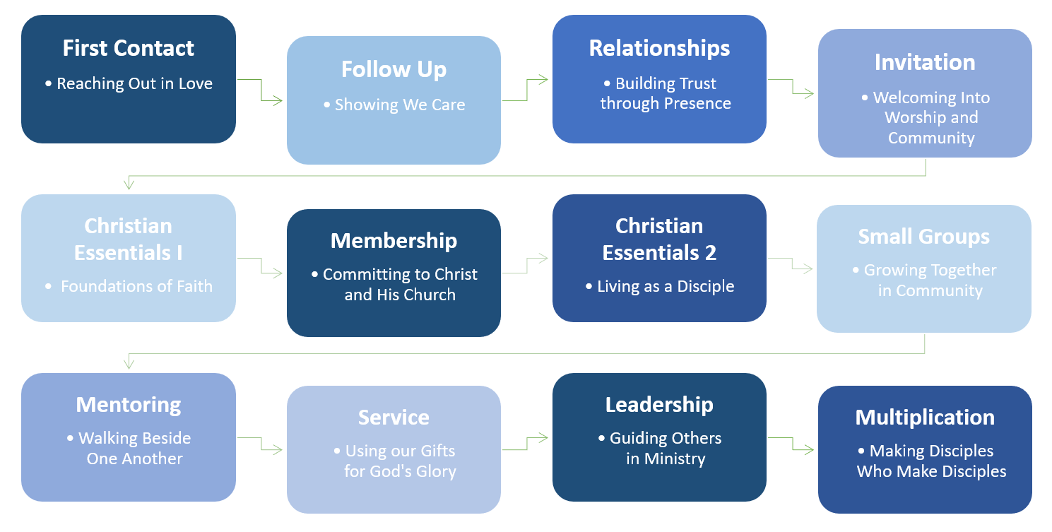

Various optional steps / chapter headings
  - First contact
  - Follow up
  - Relationships
  - Small Group / Service / Event
  - Bible Information Course
  - Membership
  - BIC 2 (post-membership membership class)
  - Small Groups / Shepherding
  - Service / Participation
  - Serving on a Ministry Team
  - Leadership Development
  - Leadership


- Specifics within each chapter

  - First contact
    - Friendship Evangelism
    - Outreach events (both “come” and “go” strategies)
    - Social media
    - Community service

  - Follow up
    - 36 hour plan
    - Database/software/app
    - Outreach team / training
    - Monthly prospect newsletter/email/text
    - Special event invitations

  - Relationships
    - Friendship Evangelism – relationship / gospel communication training
    - “Prospect shepherding” by outreach team members

  - Small Groups
    - Resource: Sticky Church by Larry Osbourne

  - Service/Event
    - Community Service projects
    - Service opportunities for non-members at church / in congregation’s ministry
    - Formal congregational fellowship events
    - Informal events organized by congregational members

  - Bible Information Course
    - Member with whom they have a relationship also attends
    - One on one with pastor or in small groups

  - Membership
    - Formal commitment/welcome in worship
    - New Member Welcome potluck (attended by leaders, elders, shepherds, Member Ministry Coordinator)
    - New Member gift
    - New Member Packet (including updated picture directory)

  - BIC 2 (post-membership membership class: congregation’s core values, DNA, mission, what it means to be a member here)
    - Course includes: encouragement for specific commitments to Means of Grace engagement, congregational core values/mission/”proven process”/future goals, mission of the Church, Body of Christ ministry/spiritual gifts, value/qualities/roles of Biblical servant leaders, ministry structure of the congregation, stewardship principles and specifics
    - Initial time and talents survey
    - Personal follow up conversation by pastor and/or Member Ministry Coordinator

  - Small Groups / Shepherding
    - Personal spiritual care component (supplemental to pastor/elders)
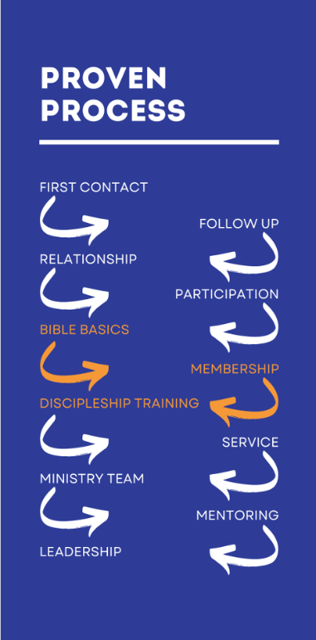
  - Service / Participation
    - Member Ministry Coordinator (job description, process, app)
    - Job descriptions for service roles
    - Identifying gifts, plugging into service opportunities
    - Service in the congregation’s ministry and service in the community (as gospel ambassadors) celebrated as equal wins
    - Semi-annual Stewardship of Time and Talent Sundays (sign up tables; “Opportunities to Serve” handout)

  - Serving on a Ministry Team
    - Next level of commitment – attending meetings, participating in planning/organizing/executing ministry

  - Leadership Development
    - Small groups can be a part of this (hosting/leading)
    - Resource: Congregational Assistance Program (CAP) studies
    - Annual Leadership Training seminars
    - Mentoring
    - “5 Essentials of a Ministry Team” workshop (GIA)

  - Leadership
    - Job descriptions
    - Studying a book together annually (discussions at monthly meetings)
    - Annual Leadership retreats
    - Annual ministry reviews

- Variety of resources

- Next Steps:

  - Determine Proven Process priorities
  - Create intentional plan for developing the details of each chapter
  - Communicate the Proven Process to the leadership and congregation
    - Brief presentation(s) after worship
    - Detailed presentation at congregational forum
    - Other (e.g., Bible study series, video presentation, series of social media posts)
  - Every Member Visits
  - Get people plugged in

